{

$model = BlogPost::findOne(['slug'=>$slug]); if ($model === null) {

throw new NotFoundHttpException('The requested page does not exist.');

}

return $this->render('view', [

'model' => $model,

]);

}

3. That it is. If you run blogpost/slug with the slug value as sluggablebehavior-test, you will get the following result:

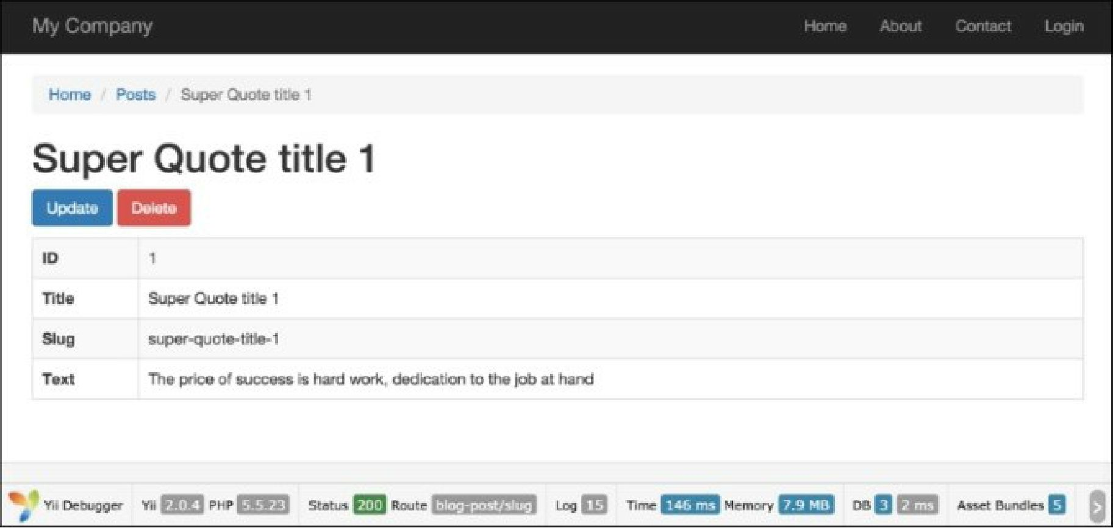

4. It’s suggested that the previous slug recipe be successfully completed with a created instance of Post model.

5. To beautify the URL, add the following urlManager component in config\web.php:

//..

'urlManager' => [

'enablePrettyUrl' => true,

'rules' => [

'blog-post' => 'blog-post/index',

'blog-post/index' => 'blog-post/index',

'blog-post/create' => 'blog-post/create',

'blog-post/view/<id:\d+>' => 'blog-post/view',

'blog-post/update/<id:\d+>' => 'blog-post/update', 'blog-post/delete/<id:\d+>' => 'blog-post/delete',

'blog-post/<slug>' => 'blog-post/slug',

'defaultRoute' => '/site/index',

],

]

//..

6. It’s important that the 'blog-post/<slug>' => 'blog-post/slug' rule is the last in the post URL